**Assignment-- April 21**

**1.What is cloud?**

The term cloud refers to a network or the internet. It is a technology that uses remote servers on the internet to store, manage, and access data online rather than local drives. The data can be anything such as files, images, documents, audio, video, and more. And we can do operations like

* Developing new applications and services
* Storage, back up, and recovery of data
* Hosting blogs and websites
* Delivery of software on demand
* Analysis of data
* Streaming videos and audios

**2.What is the difference between Cloud and Internet?**

Internet is a network of networks, which provides software/hardware infrastructure to establish and maintain connectivity of the computers around the world,

while Cloud computing is a new technology that delivers many types of resources over the Internet

1. **What are the 2 models available in Cloud?**
2. Service model.
3. Deployment model.

4.**What is a service model?**

A software distribution model in which applications are hosted by a vendor or service provider and made available to customers through the internet.

5 .**what is IAAS, Explain?**

### **Infrastructure as a Service (IaaS)**

Infrastructure as a Service (IaaS) is a self-service model for managing remote data center infrastructures. IaaS provides virtualized computing resources over the Internet hosted by a third party such as Amazon Web Services, Microsoft Azure or Google. Instead of an organization purchasing hardware, companies purchase IaaS based on a consumption model. It is like buying electricity. You only pay for what you use. This model enables companies to add, delete or reconfigure IT infrastructure on-demand. Many IT organizations rely on IaaS because they are more familiar with IaaS, especially if they have years of experience with virtual environments or strict security and regulatory requirements that can only be met through IaaS.

****Example:**** DigitalOcean, Linode, Amazon Web Services (AWS), Microsoft Azure, Google Compute Engine (GCE), Rackspace, and Cisco Metacloud.

1. **What is PAAS, Explain?**

Platform as a Service (PaaS) allows organizations to build, run and manage applications without the IT infrastructure. This makes it easier and faster to develop, test and deploy applications. Developers can focus on writing code and create applications without worrying about time-consuming IT infrastructure activities such as provisioning servers, storage and backup. PaaS brings more value to cloud. It can reduce your management overhead and lower your costs. PaaS also makes it easier for you to innovate and scale your services on demand.

****Example:**** AWS Elastic Beanstalk, Windows Azure, Heroku, Force.com, Google App Engine, Apache Stratos, Magento Commerce Cloud, and OpenShift.

7.**What is SAAS, Explain?**

Software as a service (SaaS) replaces the traditional on-device software with software that is licensed on a subscription basis. It is centrally hosted in the cloud. A good example is Salesforce.com. Most SaaS applications can be accessed directly from a web browser without any downloads or installations required. However, some SaaS applications require plugins.

****Example:**** BigCommerce, Google Apps, Salesforce, Dropbox, ZenDesk, Cisco WebEx, ZenDesk, Slack, and GoToMeeting.

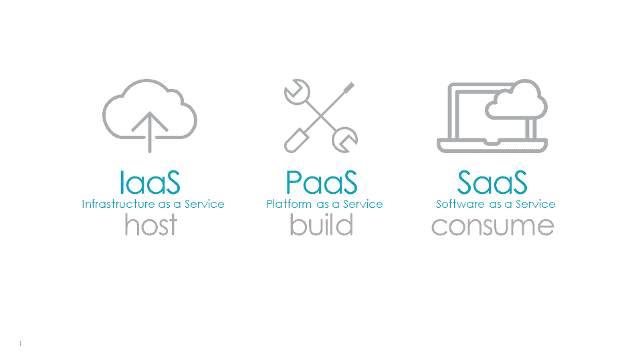

8.**What is a deployment model?**

It works as your virtual computing environment with a choice of deployment model depending on how much data you want to store and who has access to the Infrastructure.

**9.What is a private cloud?**

Private cloud is operated solely for an organization and the cloud may be on or on the premises.

10.**what is Community cloud?**

Community cloud is shared by several organizations and supports a specific community of customers that have similar information technology requirements.

**11.What is a public cloud?**

Public has an infrastructure that is made available to the general public or large scale industry.

**12.What is Hybrid cloud?**

Hybrid cloud has an infrastructure that is composed of two or more clouds that remain unique entities but are bound together by standardized or proprietary technology.

**13.What are the advantages of Cloud?**

### 1) Back-up and restore data

Once the data is stored in the cloud, it is easier to get back-up and restore that data using the cloud.

### 2) Improved collaboration

Cloud applications improve collaboration by allowing groups of people to quickly and easily share information in the cloud via shared storage.

### 3) Low maintenance cost

Cloud computing reduces both hardware and software maintenance costs for organizations.

### 4) Mobility

Cloud computing allows us to easily access all cloud data via mobile.

### 5) Unlimited storage capacity

Cloud offers us a huge amount of storing capacity for storing our important data such as documents, images, audio, video, etc. in one place.

### 6) Data security

Data security is one of the biggest advantages of cloud computing. Cloud offers many advanced features related to security and ensures that data is securely stored and handled.